Urinary Tract Infections Chromogenic Medium

Product No. | Product Category | Specification
CRM022B | Dehydrated Culture Medium | 500g/bottle

Intended Use
For isolation and identification of urinary tract pathogens.

Principle and Interpretation
Peptoneand yeast extract supply essential nutrients and vitamins in this medium. Chromogenic mixdetermines the color of different pathogens in genus level. Agar is coagulant.

Formulation
Ingredients | /liter
Peptone | 12.0 g
Yeast extract | 5.0 g
Chromogenic mix | 1.0 g
Agar | 15.0 g
pH 7.0±0.2 at 25°C

Preparation
Suspend 33.0g in 1 L distilled or deionized water. Heat with frequent agitation and boil to completely dissolve the powder. Distribute into flasks. Autoclave at 121℃ for 15 minutes.

Quality Control
Cultural characteristics observed after incubation at 35-37°C for 18-24 hours
Quality control strains | Approx. Inoculum(CFU) | Recovery | Growth
Escherichia coli ATCC25922 | 10-100 | PR≥0.5 | Purple-red colonies
Enterococcus faecalis ATCC29212 | 10-100 | PR≥0.5 | Turquoise colonies
Citrobacter fischeri ATCC43864 | 10-100 | PR≥0.5 | Metallic blue with red halo colonies
Staphylococcus saprophyticus FSCC(I)223042 | 10-100 | PR≥0.5 | Light pink colonies
Staphylococcus aureus ATCC 6538 | 10-100 | PR≥0.5 | White to gold colonies
Streptococcus agalactiae ATCC12386 | 10-100 | PR≥0.5 | Sapphirine colonies
Pseudomonas aeruginosa ATCC27853 | 10-100 | PR≥0.5 | Translucent colonies,may be a faint green pigment
Proteus mirabilis CMCC(B)49005 | 10-100 | PR≥0.5 | Brown halo colonies

Storage and Shelf Life
Dry powder was stored in a sealed container at 2-30℃ for two years in a dry environment. The prepared plates were stored at 2-8℃ for one week ,Use before expiry date on the label.

Precautions
1. When weighing the dehydrated medium, please wear masks to avoid causing respiratory system discomfort
2. Keep container tightly closed after using to prevent clumping.

Waste Disposal
Microbiological contamination was disposed by autoclaving at 121°C for 30 minutes.

Revision
December1, 2024

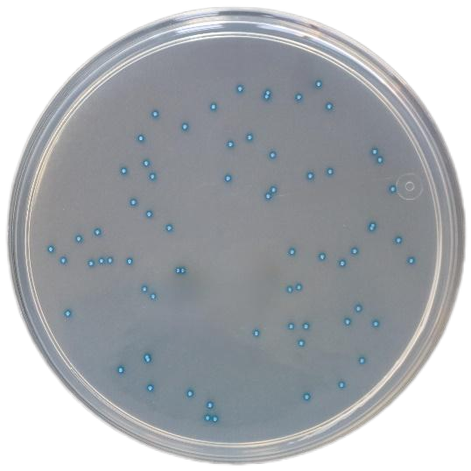
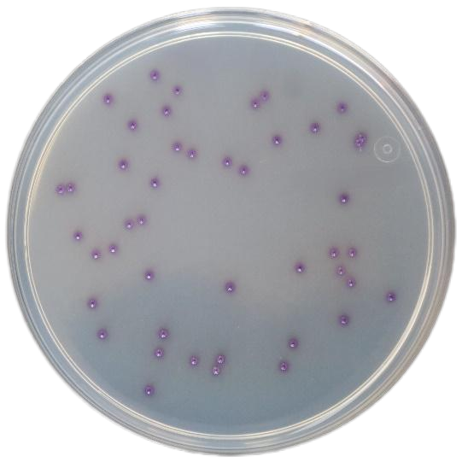

Escherichia coli: Purple-red colonies Enterococcus faecalis: Blue-green colonies

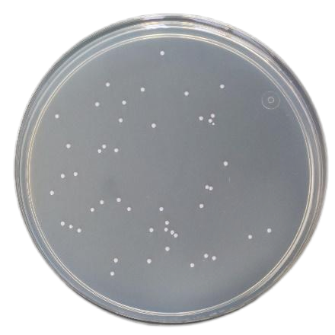
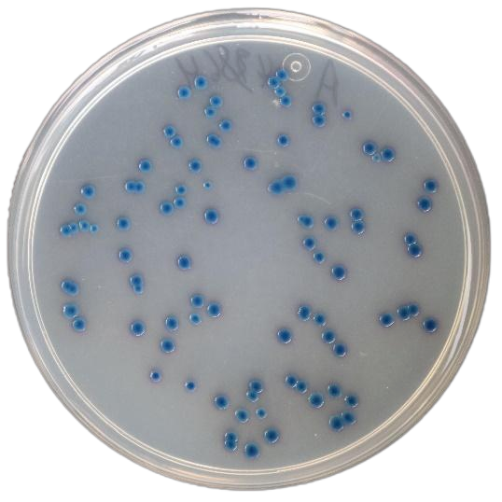

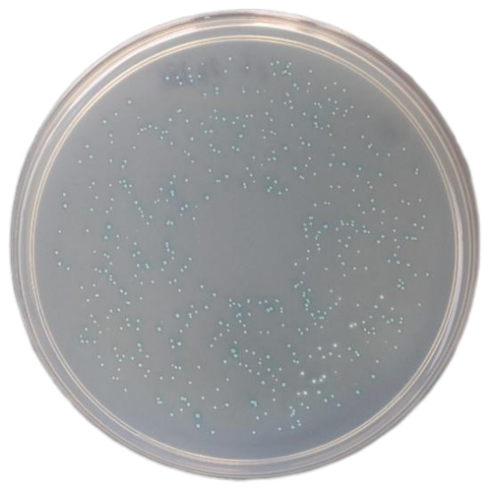
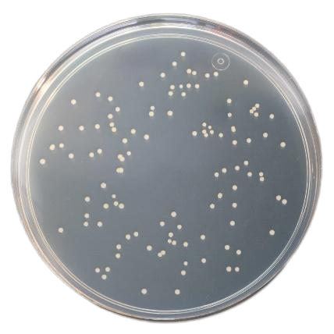
Citrobacter fischeri：Metallic blue with red halo colonies Staphylococcus saprophyticus：Light pink colonies

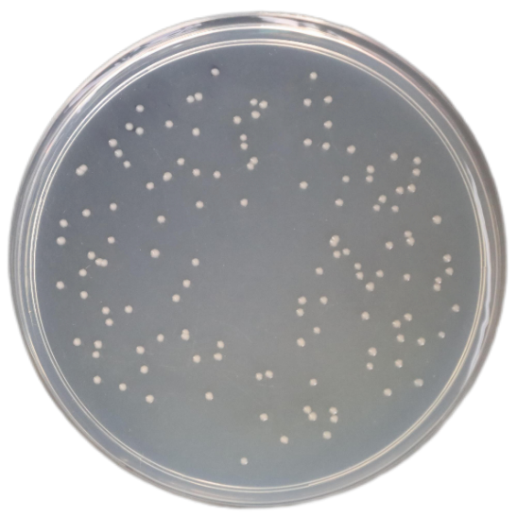
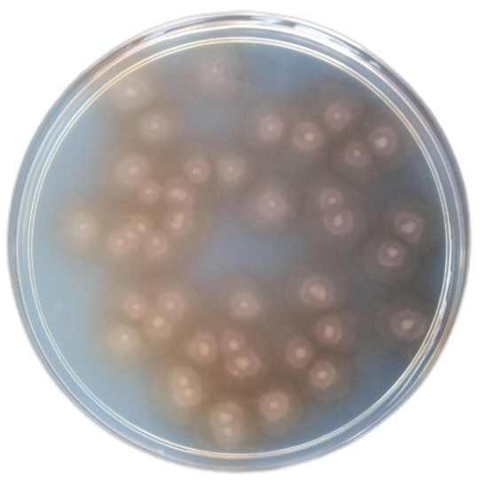
Staphylococcus aureus：White to gold colonies Streptococcus agalactiae：Sapphirine colonies

Pseudomonas aeruginosa： Proteus mirabilis：Brown halo colonies
Translucent colonies,may be a faint green pigment

