Chromogenic Yersinia Enterocolitica Agar

Product No. | Product Category | Specification
CRM017C | Dehydrated Culture Medium | 500g/bottle

Intended Use
For the detection and differentiation of pathogenic Yersinia enterocolitica.

Principle and Interpretation
Peptone provides nitrogen sources, vitamins, and growth factors.Salts maintain osmotic balance; agar acts as the solidifying agent.Inhibitors (supplementary reagents) suppress contaminating flora.Chromogenic substrates react specifically with enzymes produced by pathogenic Yersinia enterocolitica, hydrolyzing the substrate to release chromogens. Pathogenic strains form lavender colonies, while non-pathogenic strains appear metallic blue or are inhibited.

Formulation
Ingredients | /liter
Peptone | 9.0g
Salts | 5.0g
Chromogenic mixture | 1.4g
Agar | 15.0g
pH 7.0±0.2 at 25°C

Preparation
Weigh 30.4 g of the dry powder and dissolve in 1000 mL of distilled or purified water.Stir and heat to boiling until fully dissolved.Cool to approximately 50°C.Add 1 vial of lyophilized supplement (SR0770) per 100 mL medium. Mix thoroughly.Pour into sterile Petri dishes under aseptic conditions.

Quality Control
Cultural characteristics observed after incubation at 35-37°C for 24 hours
Quality control strains | Approx. Inoculum(CFU) | Recovery | Characteristics
Y. Enterocolitica CMCC(B)52204 | 10-100 | PR≥0.5 | Magenta colonies
Y. enterocolitica GDMCC68056 | > 10⁴ | Growth observed | Dark blue colonies
Escherichia coli ATCC 25922 | > 10⁴ | G≤1 | No growth
Enterococcus faecalis ATCC 29212 | > 10⁴ | G≤1 | No growth

Storage and Shelf Life
2-30℃，Keep container tightly closed, avoid direct sunlight.
Use before expiry date on the label.

Precautions
1. When weighing the dehydrated medium, please wear masks to avoid causing respiratory system discomfort
2. Keep container tightly closed after using to prevent clumping.

Waste Disposal
Microbiological contamination was disposed by autoclaving at 121°C for 30 minutes.

Revision
On June 14, 2024
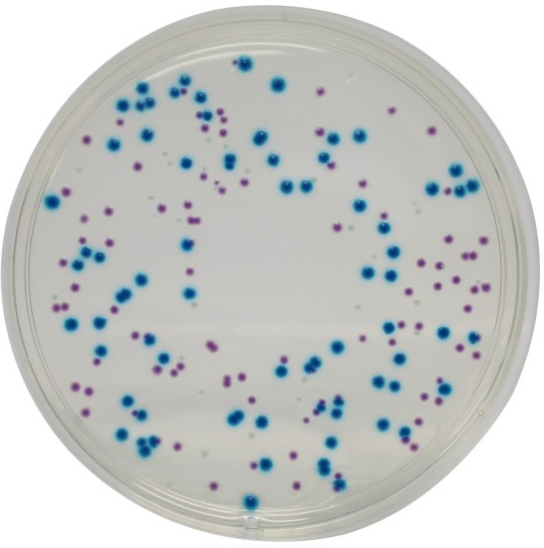

Pathogenic Yersinia enterocolitica: Magenta colonies
Non-pathogenic strains: Dark blue colonies or inhibited/no growth

