Chromogenic Candida Agar

Product No. | Product Category | Specification
CRM016B | Dehydrated Culture Medium | 500g/bottle

Intended Use
For the selective isolation and presumptive identification of Candida, particularly Candida albicans.

Principle and Interpretation
Peptone provides carbon and nitrogen sources.Agar acts as the solidifying agent for the culture medium.Chloramphenicol inhibits the growth of contaminating microorganisms.Chromogenic substrates specifically react with enzymes produced by Candida.hydrolyzing the substrate to release a chromogen. Candida albicans forms green to blue-green colonies due to its enzymatic activity.

Formulation
Ingredients | /liter
Peptone | 10.2g
Chromogen Mixture | 22.0g
Agar | 15.0g
Chloramphenicol | 0.5g
pH 6.3±0.2 at 25°C

Preparation
Weigh out 47.7 g of this medium, add it to 1000 mL of distilled or deionized water, stir, heat, and bring to a boil until completely dissolved. Once cooled to approximately 50℃, pour into sterile Petri dishes under aseptic conditions. Allow the medium to solidify before use.

Quality Control
Cultural characteristics observed after incubation at 30-35°C for 48-72 hours
Quality control strains | Approx. Inoculum(CFU) | Recovery | Characteristics
Candida albicans ATCC 10231 | 10-100 | PR:0.5-2.0 | Green-blue-green colonies
Candida krusei ATCC 34135 | > 10⁴ | - | Purple-red colonies, irregular edges
Candida glabrata ATCC 15126 | > 10⁴ | - | Pink periphery with purple-red center
Candida tropicalis ATCC 1369 | > 10⁴ | - | Steel-blue colonies
Escherichia coli CMCC(B)44102 | > 10⁴ | G≤1 | No growth

Storage and Shelf Life
2-30℃，Keep container tightly closed, avoid direct sunlight.
Use before expiry date on the label.

Precautions
1. When weighing the dehydrated medium, please wear masks to avoid causing respiratory system discomfort
2. Keep container tightly closed after using to prevent clumping.

Waste Disposal
Microbiological contamination was disposed by autoclaving at 121°C for 30 minutes.

Revision
On June 14, 2024
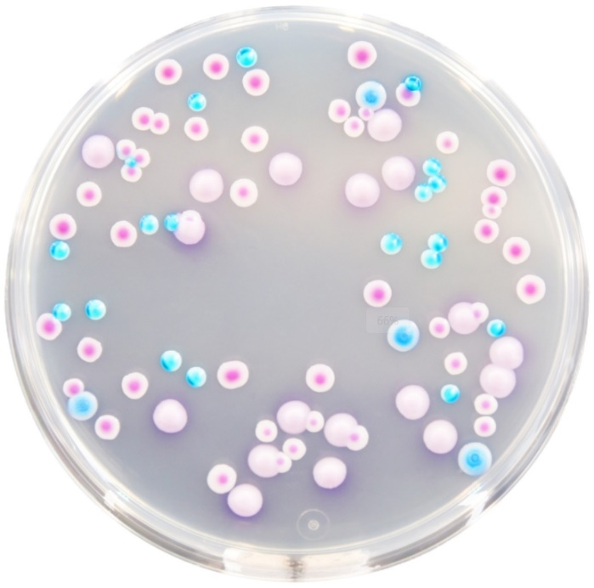

Candida albicans: Green-blue-green colonies
Other microbes: Magenta colonies, steel-blue colonies, or inhibited/no growth

