Chromogenic L.monocytogenes Agar

Product No. | Product Category | Specification
CRM013B | Dehydrated Culture Medium | 500g/bottle

Intended Use
For the isolation and presumptive identification of Listeria monocytogenes.

Principle and Interpretation
Peptone and yeast extract powder provide carbon, nitrogen sources, and trace elements.Sodium chloride maintains osmotic balance.Agar acts as the solidifying agent.Chromogenic substrates react specifically with enzymes produced by Listeria monocytogenes, hydrolyzing the substrate to release a chromogen, resulting in blue-green, smooth, regular colonies on the medium.Inhibitors and supplementary reagents suppress the growth of contaminating microorganisms.

Formulation
Ingredients | /liter
Peptone | 15.0g
Yeast extract powder | 5.0g
Sodium chloride | 5.0g
Agar | 15.0g
Inhibitor | 5.0g
Chromogenic mixture | 2.3g
pH 7.1±0.2 at 25°C

Preparation
Weigh 47.3 g of the medium base and add to 1000 mL of distilled or deionized water.Stir and heat to boiling until fully dissolved.Autoclave at 121°C for 15 minutes, then cool to approximately 50°C.Dissolve 10 tubes of supplementary reagent (SR0480) in 10 mL of sterile water (1 mL per tube).Add the dissolved reagent to the cooled medium base and mix thoroughly.Pour into sterile Petri dishes under aseptic conditions.

Quality Control
Cultural characteristics observed after incubation at 35-37°C for 24±3 hours
Quality control strains | Approx. Inoculum(CFU) | Recovery | Characteristics
Listeria monocytogenes ATCC 19115 | 10-100 | PR≥0.7 | Blue-green, smooth, regular colonies
Listeria innocua ATCC 33090 | > 10⁴ | - | Colorless, smooth, regular colonies
Escherichia coli ATCC 25922 | > 10⁴ | G≤1 | No growth
Enterococcus faecalis ATCC 29212 | > 10⁴ | G≤1 | No growth
 | > 10⁴ | G≤1 | No growth
  Candida albicans ATCC 10231

Storage and Shelf Life
2-30℃，Keep container tightly closed, avoid direct sunlight.
Use before expiry date on the label.

Precautions
1. When weighing the dehydrated medium, please wear masks to avoid causing respiratory system discomfort
2. Keep container tightly closed after using to prevent clumping.

Waste Disposal
Microbiological contamination was disposed by autoclaving at 121°C for 30 minutes.

Revision
On June 14, 2024
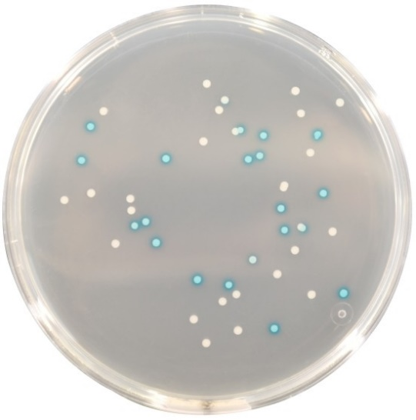

Listeria monocytogenes: Blue-green colonies, regular colonies
Other Listeria species: Colorless,, regular colonies

